LAB # 6: Processing of Multi Beam Echo-Sounding Data

Part C: Generation and Export of Bathymetric Products

Submitted by: Ryan Nguyen (216334336)

Submitted to: Jiahuan Hu

Submitted on: March 29, 2022

Course Code: ESSE 4650

Introduction

This is the last part of the 3-part multi-beam lab. This part of the lab pertains to the generation and exportation of bathymetric products of a multibeam survey.

Discussion and Results

**Deliverable C1**

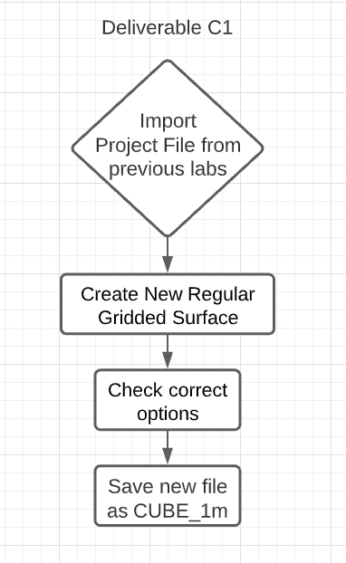

Figure 1: Deliverable C1 Workflow

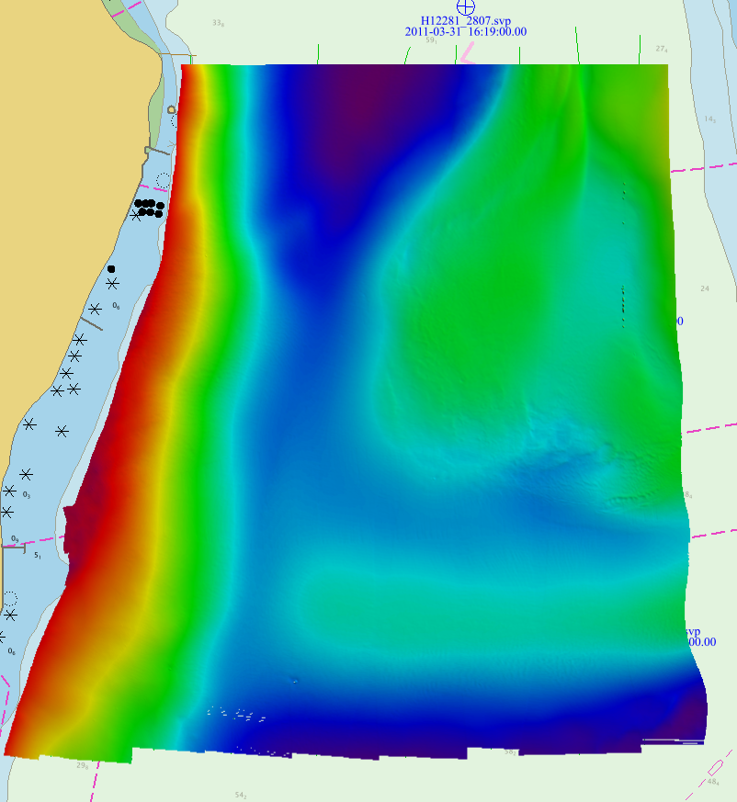

Figure 2: Generated Surface

The colours shows the range of depth of the generated surface.

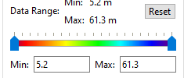

Figure 3: Colour Map of the Depth Range

**Deliverable C2**

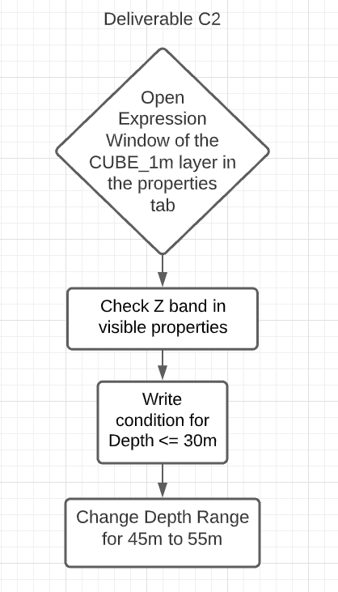

Figure : Deliverable C2 Workflow

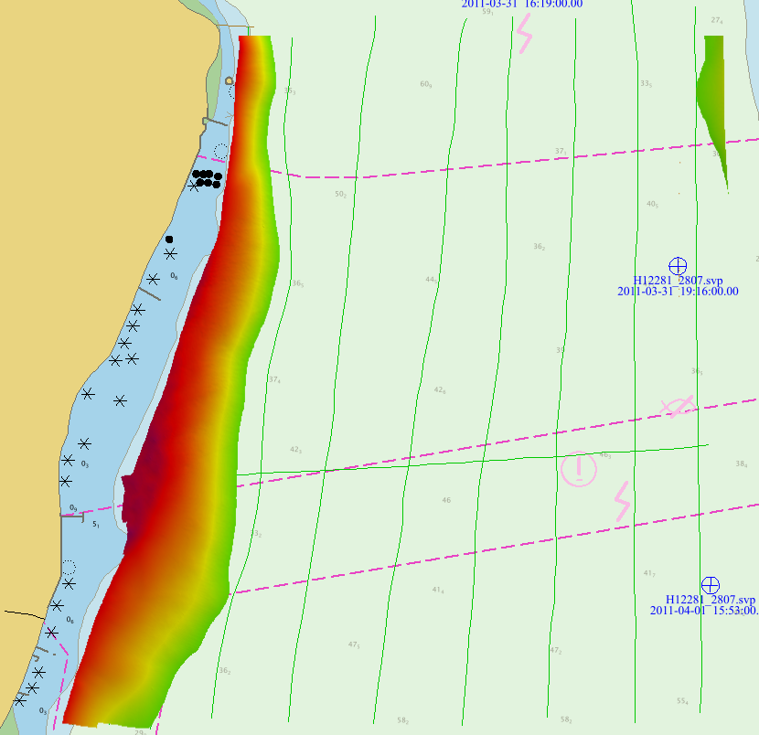

Figure : Depth <= 30 meters

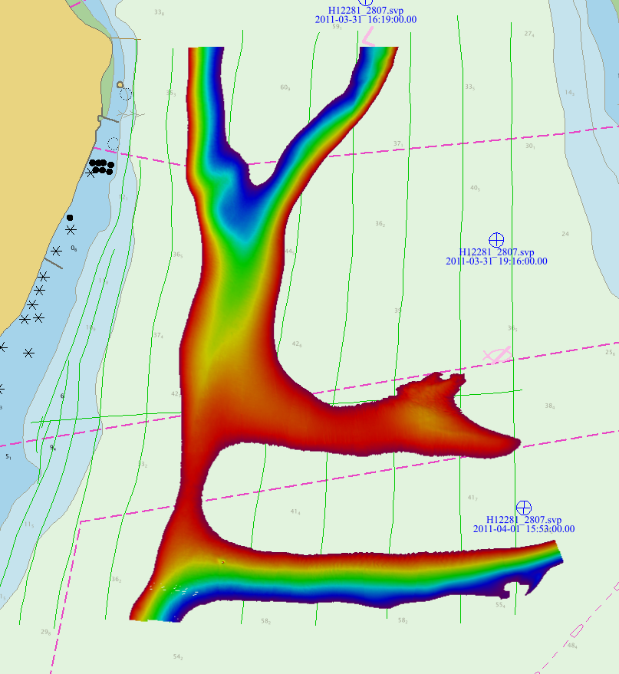

Figure : Depth Between 45m and 55m

**Deliverable C3**

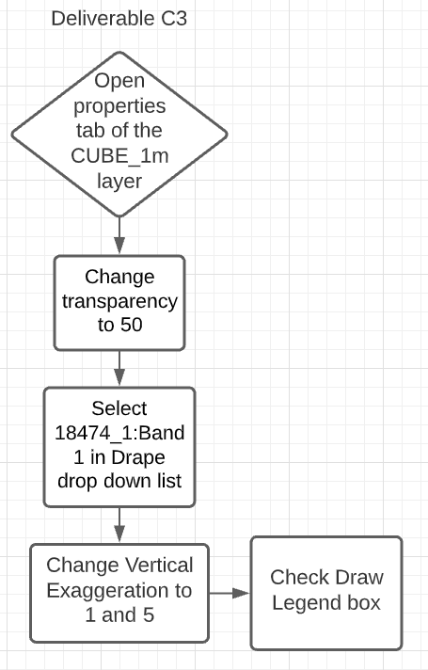

Figure : Deliverable C3

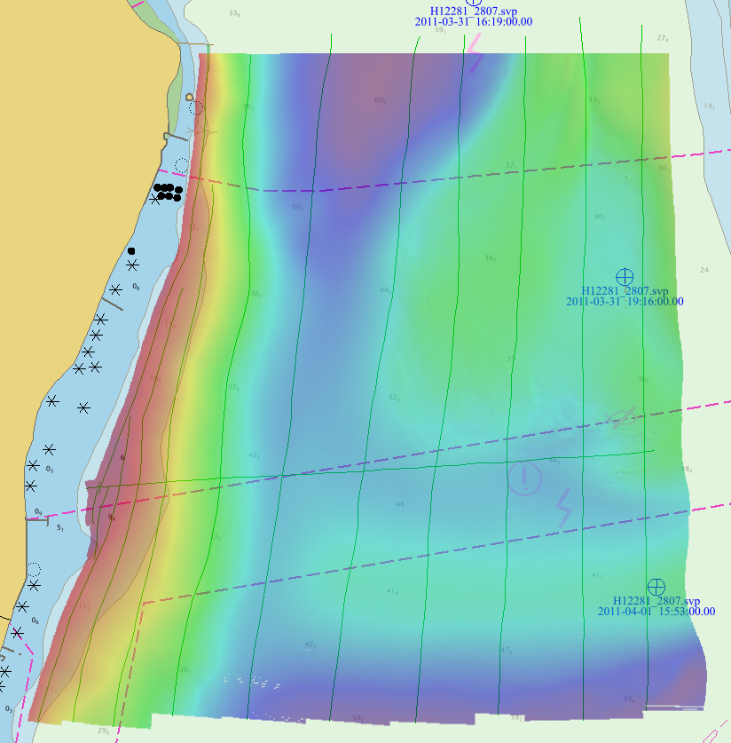

Figure : Surface Layer set at 50 Transparency

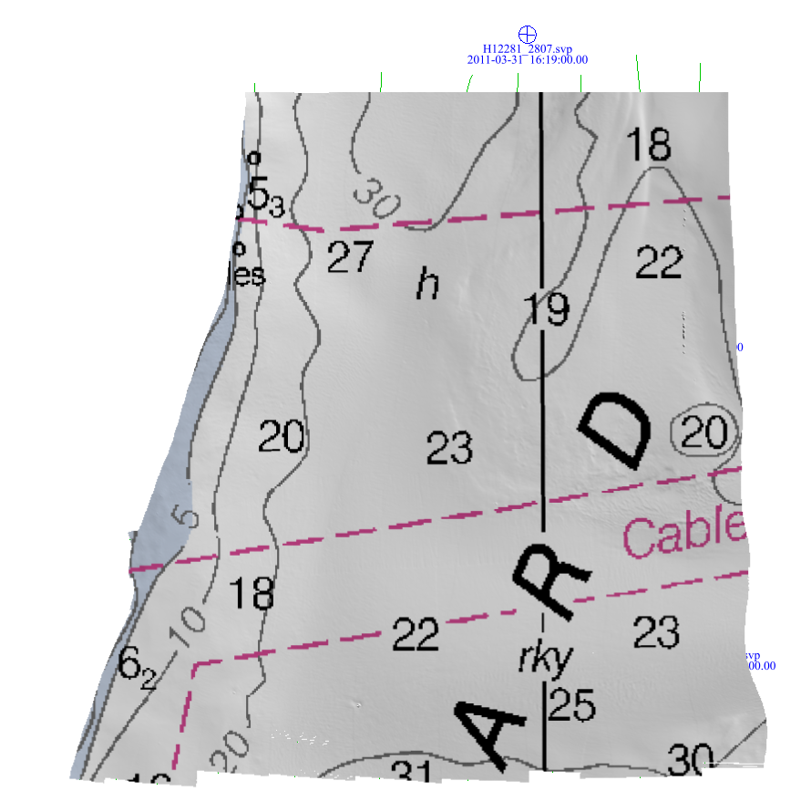

Figure : Surface Layer with Vertical Exaggeration of 1

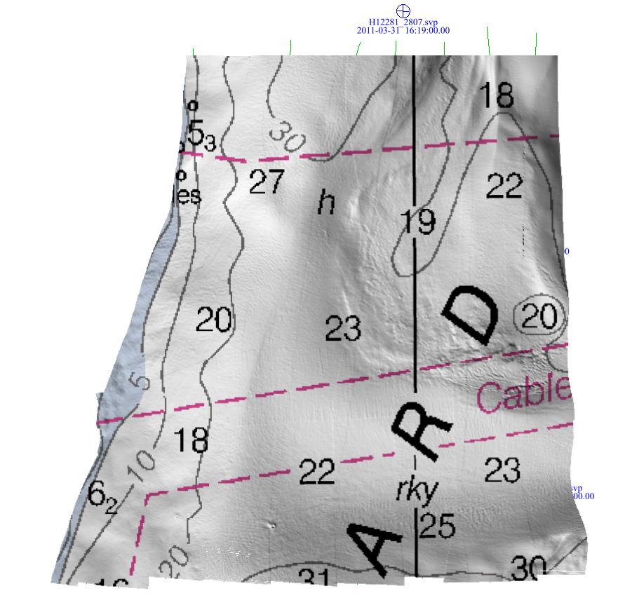

Figure : Surface Layer with Vertical Exaggeration of 5

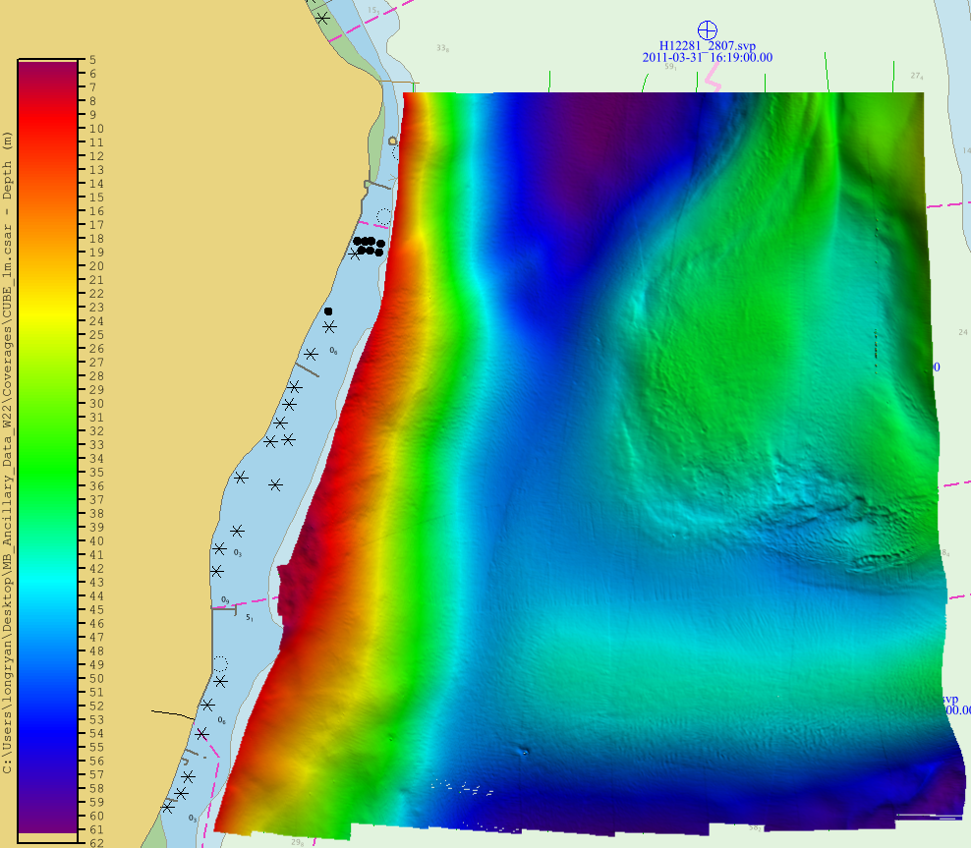

Figure : Surface Layer with the Colour Depth Legend

**Deliverable C4**

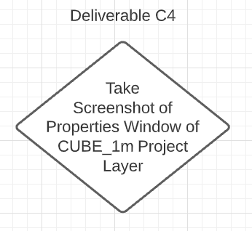

Figure : Deliverable C4 Workflow

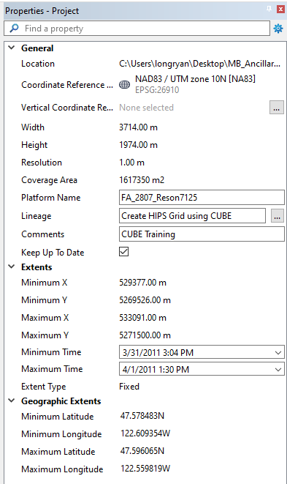

Figure : Screen Capture of Properties Window

**Deliverable C5**

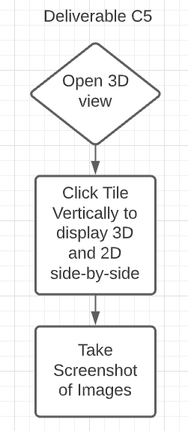

Figure : Deliverable C5 Workflow

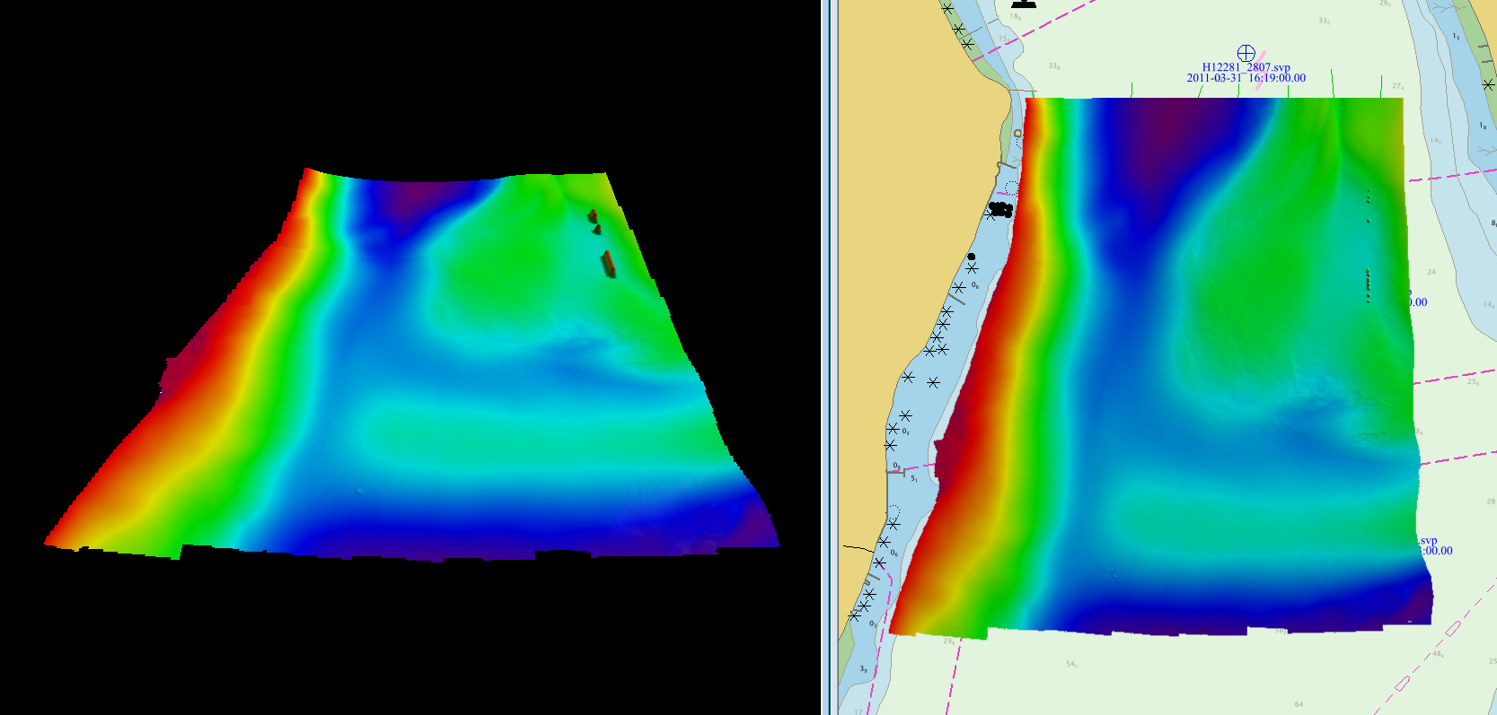

Figure : 3D and 2D View of CUBE_1m Layer

**Deliverable C6**

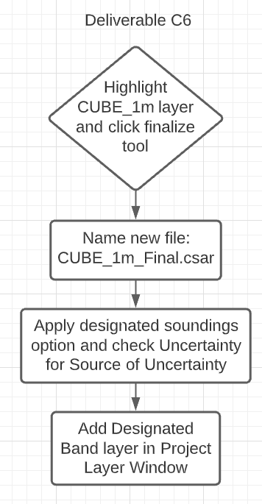

Figure : Deliverable C6 Workflow

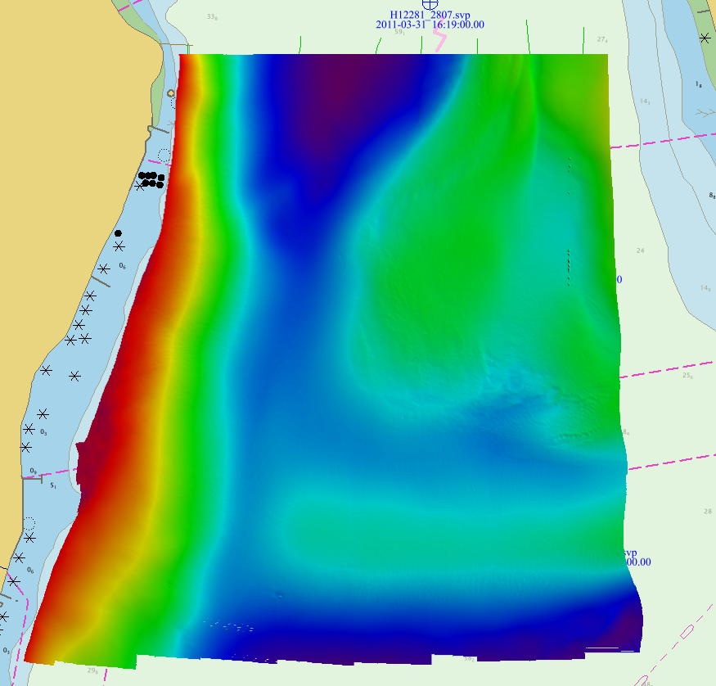

Figure : Surface Finalization of CUBE_1m Layer

**NOTE: Designated band was not found in CUBE_1m_Final.csar**

There is a slight difference between the final file and the initial file in which the small white dots found near the bottom of the layer looks more filled.

**Deliverable C7**

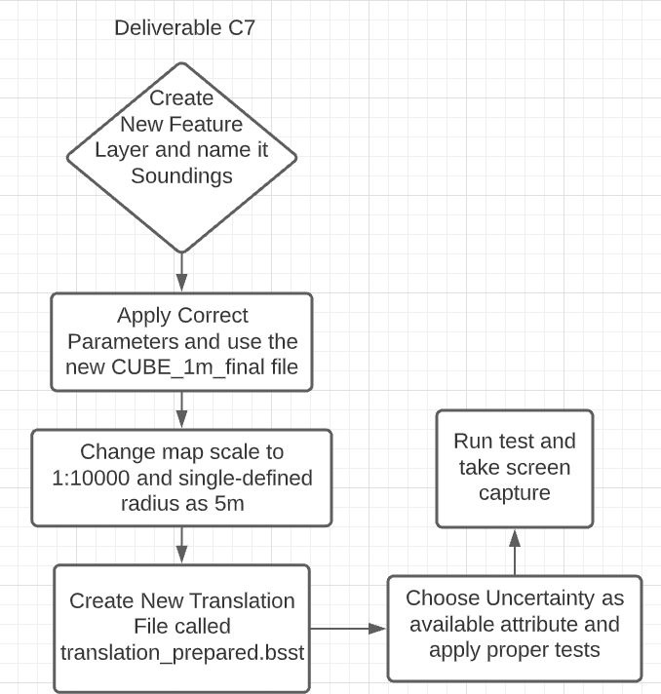

Figure : Deliverable C7 Workflow

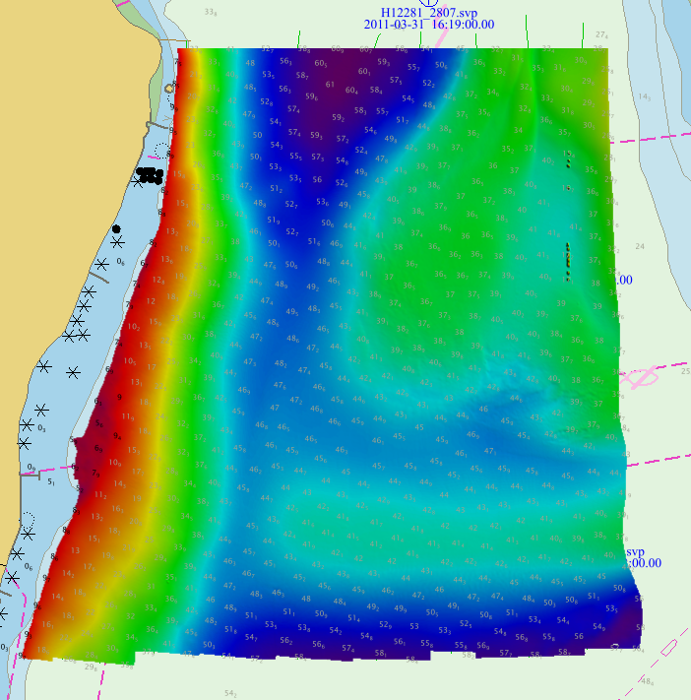

Figure : Sounding Selection with CUBE_1m_final Layer

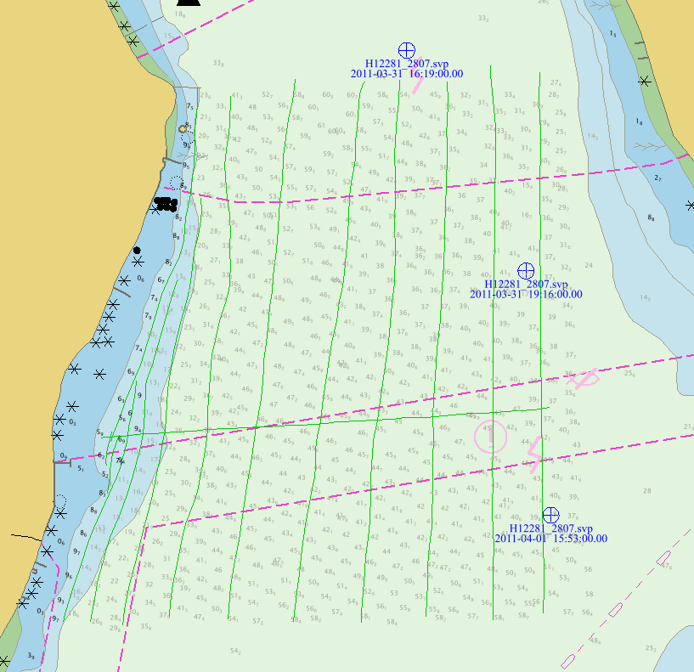

Figure : Sounding Selection without CUBE_1m_final Layer

**Deliverable C8**

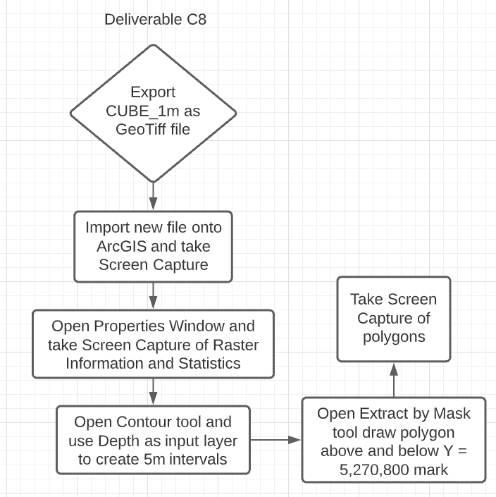

Figure : Deliverable C8 Workflow

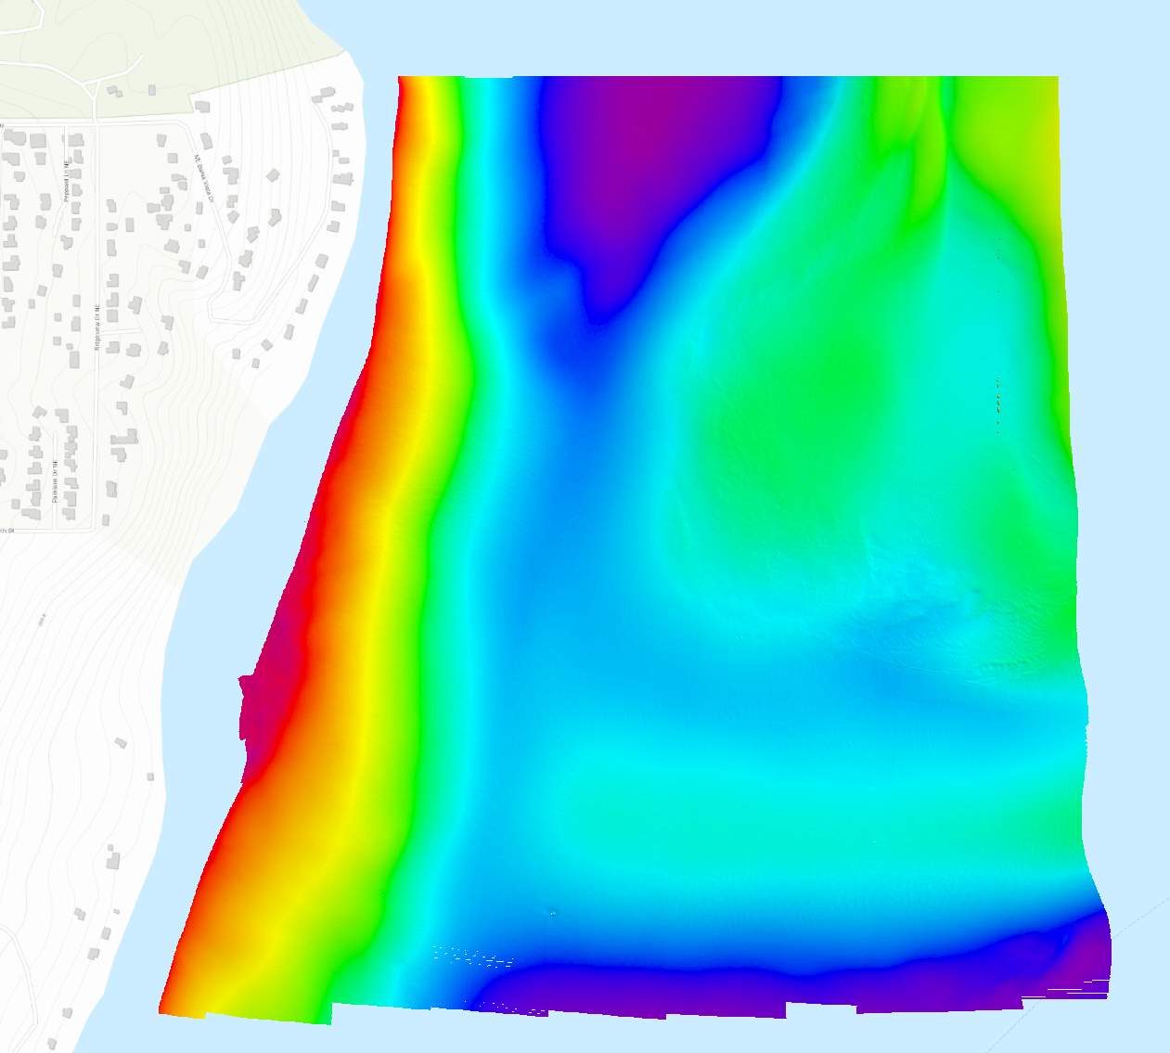

Figure : GeoTiff file Imported onto ArcGIS

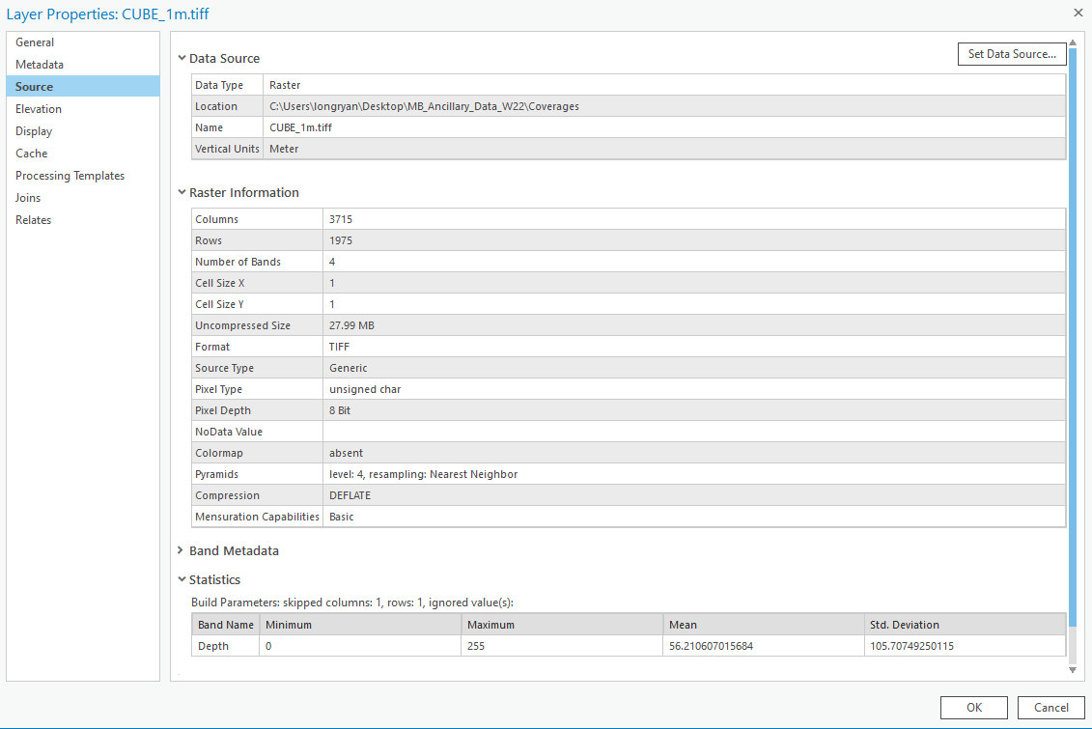

Figure : Pixel Values in Layer Properties

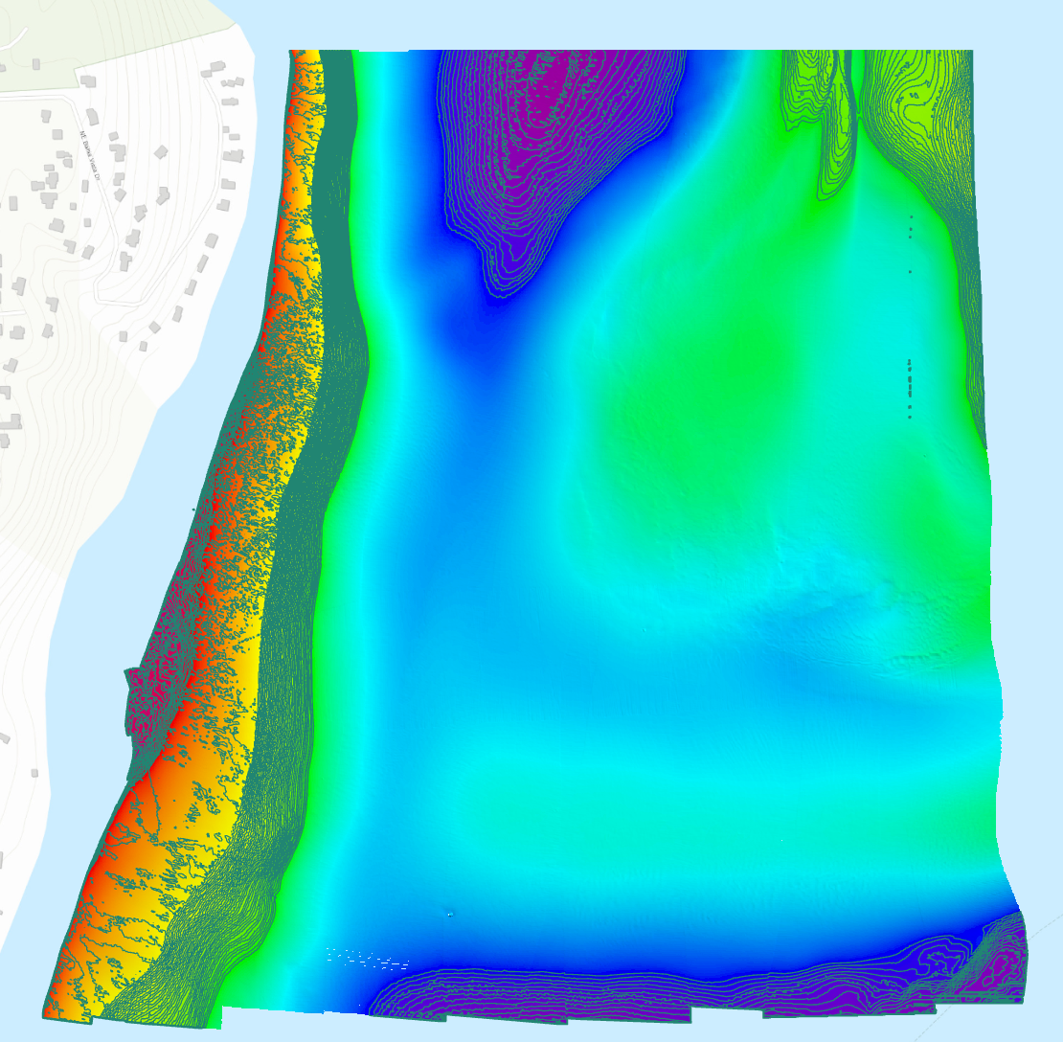

Figure : 5m Contour Intervals of Depth Band

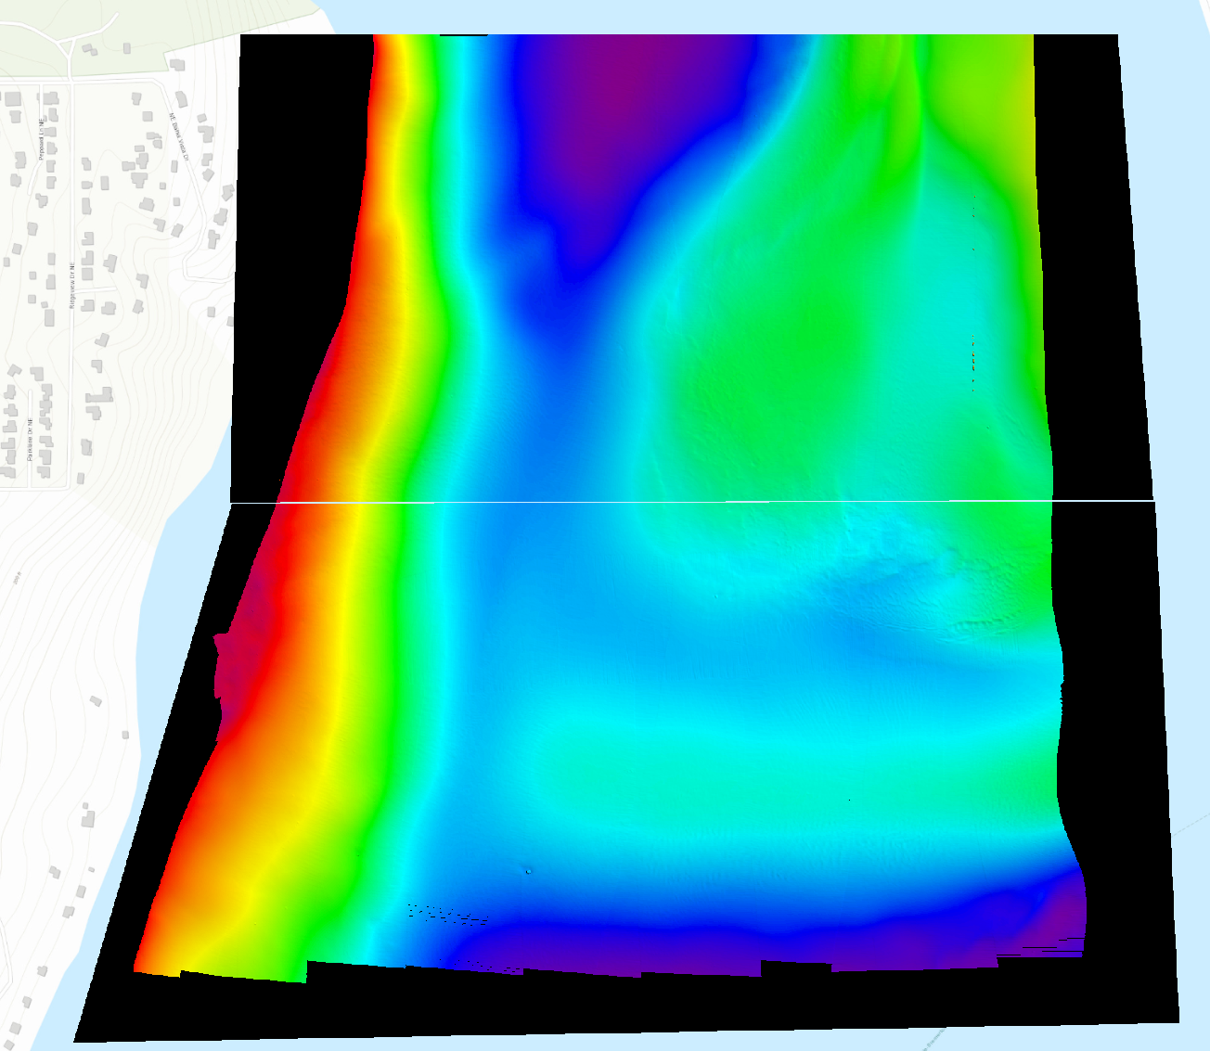

Figure : West-East Seafloor Profile at Y = 5,270,800 m

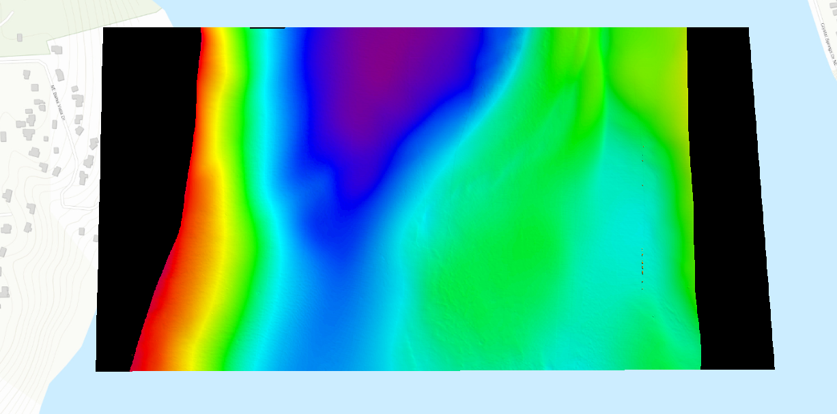

Figure 26: West-East Seafloor Profile above Y = 5,270,800 m

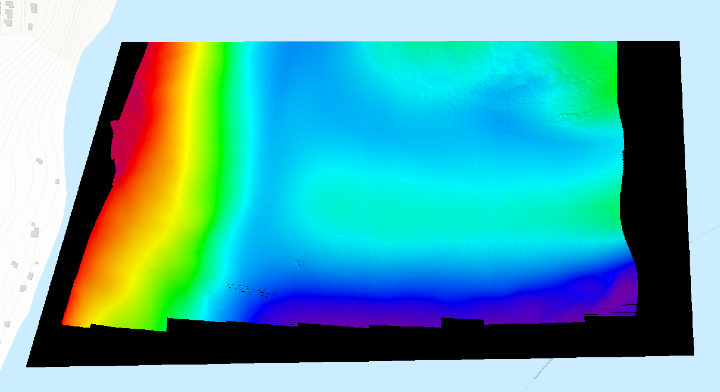

Figure 27: West-East Seafloor Profile below Y = 5,270,800 m